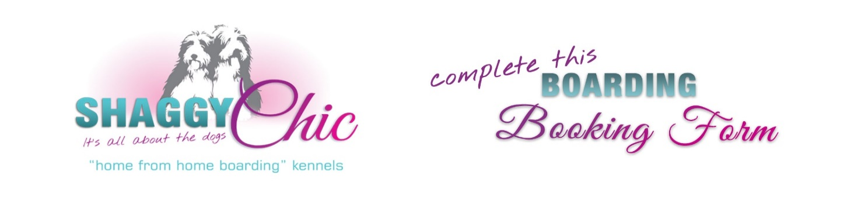
Boarding rates excluding VAT: Grooming rates excluding VAT:
1 dog: R300 per night Wash , Dry, Trim (f required) and Nails
2 dogs: R530 per night Puppy/Small: R250
3 dogs: R700 per night Medium: R300
Large: R350
A discounted day care rate of R120 is charged for dogs collected after 12 midday. XL : R400
Special long-term boarding rates are available upon request. Dogs that are extremely matted to be quoted.
Nail trim: R60
Our operating hours are strictly as follows:
Weekdays: 8am to 6pm
Saturdays: 8am to 4pm
Sundays & Public Holidays: 4pm to 5pm for collections and drop offs only

Pet Taxi: Please contact us for information.

Name of Owner:
Mobile Number: |  |  |  |  |  |  |  |  | Alternative Number:
Email Address:
Arrival Date: |  |  |  |  |  |  |  |  | Arrival Time:
Collection Date: |  |  |  |  |  |  |  |  | Collection Time:
Residential Address:
How did you hear about us?

Referral | Google |  |  | Website |  | Facebook |  | FB Community Page |  | Instagram |  |  | Brochure |  | Other (Specify)
Dog’s Name (1): |  |  |  |  |  |  |  |  |  |  | Age: |  |  |  |  | Sex:
Breed: |  |  |  |  |  |  |  |  |  |  |  |  |  | Micro Chip Number:
Food / Feeding Instructions:
Medication/Mobility/Health Problems:
Spayed/Neutered: Yes or No |  |  |  |  |  |  |  |  |  |  |  |  |  | Weight:
Behavioural Problems:
Grooming Required prior to departure: Yes or No
Dog’s Name (2): |  |  |  |  |  |  |  |  |  |  | Age: |  |  |  |  | Sex:
Breed: |  |  |  |  |  |  |  |  |  |  |  |  |  | Micro Chip Number:
Food / Feeding Instructions:
Medication/Mobility/Health Problems:
Spayed/Neutered: Yes or No |  |  |  |  |  |  |  |  |  |  |  |  |  | Weight:
Behavioural Problems:
Grooming Required prior to departure: Yes or No

Veterinary Surgeon: |  |  | Contact Number:

No dog will be accepted without a current vaccination certificate, including kennel cough (this should be given no less than 2 weeks prior to arrival). We also recommend that your dog be treated for ticks and fleas and be dewormed prior to arrival.

DISCLAIMER:

- I understand that whilst every care will be given to my dog(s), they are boarded entirely at my own risk.
- I authorise you to seek veterinary advice for my dog, should you deem it necessary and I agree to cover all costs for any veterinary bill incurred.
- Should any damages be incurred to the property by my dog during his/her stay, or should the staff be injured in any way, due to a dog bite, I undertake to reimburse Shaggy Chic for the costs thereof.

Payment in full is required upfront.

Shaggy Chic Pet Services (Pty) Ltd
ABSA Bank, Midrand
Cheque Account: 41 0594 2886
Branch Code: 632005
Absa Swift Code: ABSAZAJJ

Signed: |  |  | Date:

Name:

CHECKLIST:

- Food (provided in a sealable container, clearly labelled with the dog’s name and feeding instructions).
- Veterinary certificates.
- Treats (optional).
- Medication, if required (clearly labelled).
- Proof of payment.
- Please do not bring bowls or bedding. We use stainless steel bowls which are cleaned daily.
- Please retain leads.

We look forward to welcoming your pets to our home away from home.

For further information, please contact Eileen Ashton on 082 551 5282 or info@shaggychic.co.za .

